The Science of Chemistry- Chapter One
Section 1- What is Chemistry?
- Chemistry deals with:

…so what is a chemical?
A chemical is any substance that has a __________________________________- meaning it is always made of the same stuff no matter where it comes from
…okay, so where do chemicals come from?
1- (water and carbon dioxide)
2- (polyethylene plastic)
3- (aluminum)
…and why is chemistry important?
- We depend on chemicals every day!

- Chemical reactions happen all around us!

What is matter?

- All matter is made of ________________________________
  - The type and arrangement of particles in the matter determine its properties

- There are 3 states of matter
  - 1-
  - 2-
  - 3-
Solids
- Have a _____________________________________________

- Particles are held _____________________________________
- Vibrate very slightly

Liquids
- Have a fixed ________________ but not a fixed ________________
- Particles are not held as tightly together as solids, they slip past one another
  - This slippage allows liquid to flow and take the shape of its container

Gases
- Have __________________ a fixed volume or shape

- Particles move ________________________________________ and bounce off one another

- Will fill any container because the particles ___________________________from one another

Matter is constantly changing!
  - Ice melts
  - Milk goes sour
  - Metal rusts
- These changes are categorized into:
  - 1-
  - 2-
Physical Changes

- Examples:
  - Sugar dissolves into tea
  - Rocks are broken into pieces
  - Paper ripped

Chemical Changes

- Can be shown in an equation
Reactant(s) Product(s)
mercury oxide mercury + oxygen
- Reactions rearrange what makes up the reactant and product, nothing is lost or gained, so mass does not change
- How can you tell if a chemical change happened?

  - It may be happening if:
    - _____________________ is formed
    - _________________________________ is formed (clear turns cloudy/small solids)
    - Release/absorption of __________________ occurs (change in temp or giving off light)
    - ________________ changes
BUT…some physical changes also have these signs!

- Section 2- Describing Matter
  - Remember…matter is anything that has ____________________ and ____________________!

  - When talking about mass and volume you always need to identify the unit of measurement!
- Units of Measurement

  - There are 5 common base units in chemistry

What are we measuring? | Symbol | Unit used | Abbreviation of unit
Length | l | Meter | m
Mass | m | Gram | g
Time | t | Second | s
Thermodynamic temp. | T | Kelvin | K
Amount of substance | n | Mole | mol

  - These base units can be too large or small for some measurements, so they can be modified by adding pre-fixes.

Prefix | Abbreviation | Means | Example
Kilo- | k | 1,000 | 1 kilometer (km)= 1,000 m
Hecto- | h | 100 | 1 hectometer (hm)= 100 m
Deka- | da | 10 | 1 dekameter (dam)= 10 m
 |  | 1 | 1 meter (m)
Deci- | d | ¹/₁₀ | 1 decimeter (dm)= .1 m
Centi- | C | ¹/₁₀₀ | 1 centimeter (cm)= .01 m
Milli- | M | ¹/_{1,000} | 1 millimeter (mm)= .001 m

- We can easily convert between units by moving decimals!

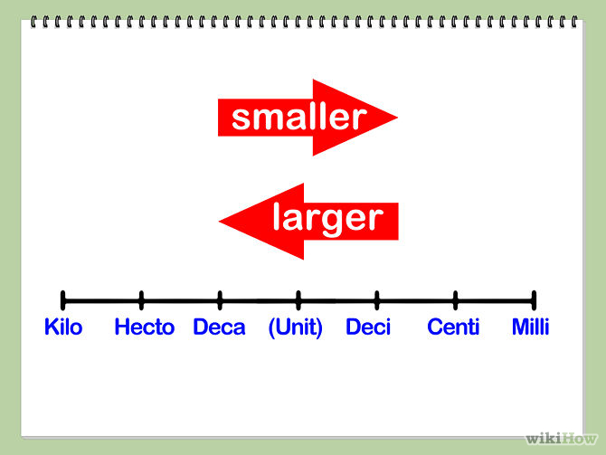
Units are:
Grams (g)
Liters (L)
Meters (m)

- Examples:

100 g = _____________ mg Move the decimal ________ places to the _________.
225.98 cm= ______________ m Move the decimal ________ places to the _________.
34.5 kL = ________________ dL Move the decimal ________ places to the _________.

- Physical Properties do not involve a chemical change and can be determined without changing the nature of the substance
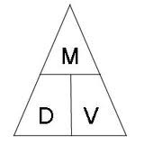
  - Examples: Density, color, mass, volume, hardness
- Density
  - The _____________________________________________ of a substance

- Density of a substance does not change with the amount of substance that you have.

- Chemical Properties describe a substances ________________________________________.
  - Can only be identified by trying to cause a chemical change
  - Examples: combustion, oxidation, decomposition

